Jamila’s GREEN LENTILS AND SPINACH IN TOMATO SAUCE

Served with basmati rice

This is one of my favourite super food dishes. It’s inspired by the Indian green lentils dhal but with an Italian twist to it. It’s delicious and full of good stuff (protein, fibre and folate) and it tastes AMAZING!!!!

WHAT YOU NEED

INGREDIENTS:

350g Green lentils 1 vegetable stock cube

A bag of fresh Spinach salt

2 gloves of garlic pepper

1 onion chilli powder (optional)

1carrot 2 cans of chopped tomatoes

1 celery stick olive oil

METHOD:

Step 1

Wash the green lentils under cold water.

Put them in a pot with lots of water and boil for 20 min.

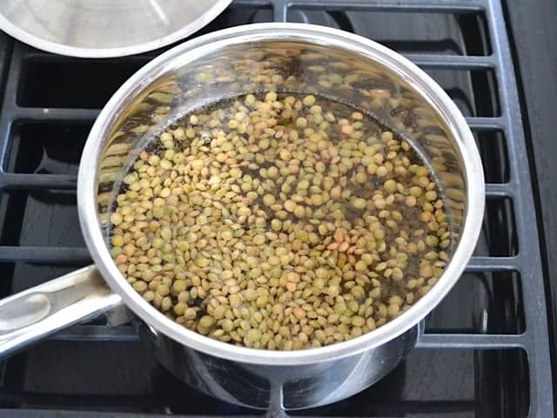

Step 2

Chop the onion carrot and celery finely.

In a large frying pan put the olive oil. Turn the fire on and when the oil is hot add the chopped ingredient

Let it fry until golden.

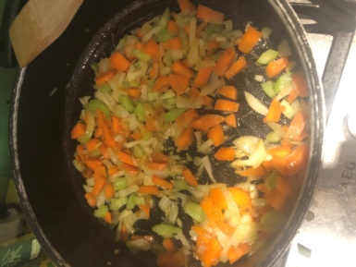

Step 3

Now add the pre boiled lentils and mix

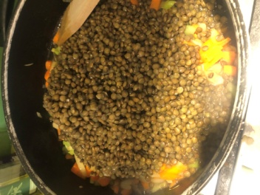

Step 4

Add the chopped tomatoes (I personally blend it so there are not tomatoes chunks)

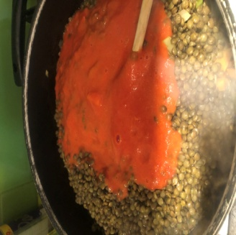

Step 5

Add the salt, pepper and chilli (I personally like it spicy)

Step 6

Add the spinach and let it simmer for 5-10 min

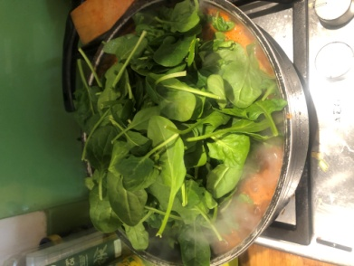 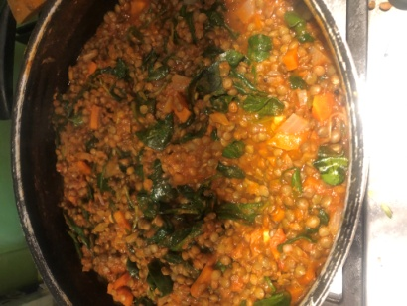

All done!

