ZOE’S MEGA “NO EGGA” SPANISH OMELETTE

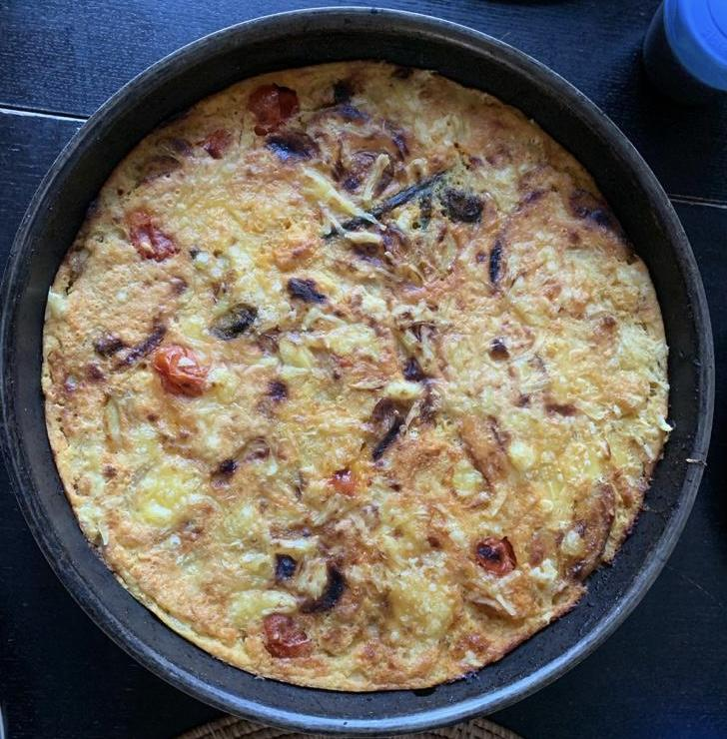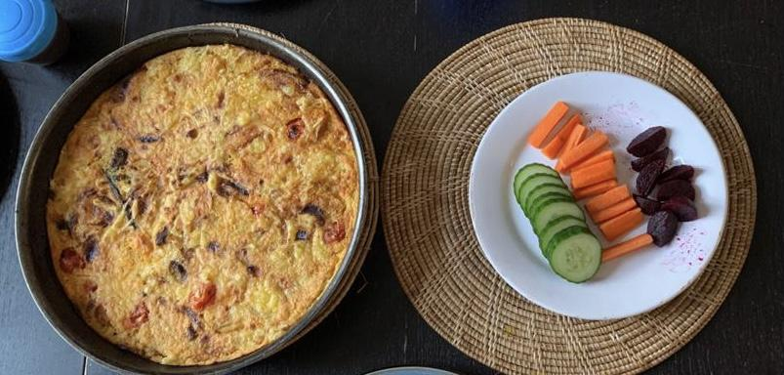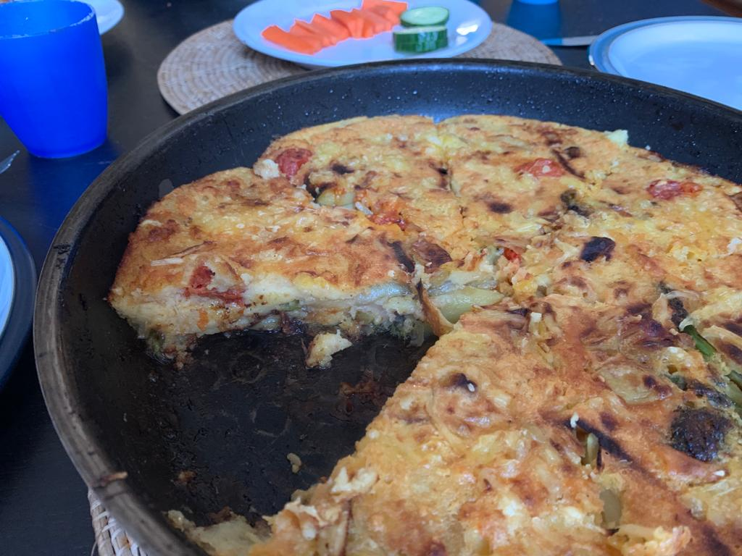

Inspiration: this yummy dish was inspired by wanting to have a Spanish style omelette, but making it vegan. It is very similar in taste but has no eggs!

**Ingredients**

1 red onion, sliced

12 baby potatoes, thinly sliced

8 cherry tomatoes

10 broccoli florets

6 asparagus tips

200g gram flour, sifted

350ml water

1 veg stock cube

1 tsp salt

1 tsp ground white pepper

50g non-dairy cheese, grated

1 tbsp olive oil

**Method**

1. Sautee the red onion, potatoes, broccoli, asparagus, and tomatoes in the olive oil in a deep pan.

2. Make 50ml of stock using 50ml of water and the stock cube. Add to the pan.

3. Make a batter by adding the remaining 300ml of water to the gram flour in a bowl. Whisk until no lumps/clumps remain. Add the salt and white pepper to the batter.

4. Pour the batter into the pan, filling all the gaps between all the vegetables. Sprinkle the top evenly with grated cheese.

5. Cook over low heat on the hob for approximately 20mins until the batter is cooked.

6. Take the pan off the hob, and put under medium grill for another 5 mins until the cheese is melted.

7. Remove from the grill, and serve with salad.