Name: April
Year: 5

How to make a Salted caramel & apple pudding

My inspiration

My inspiration is BBC good food because they make delicious recipes and my family and I always get their magazines.

Serves six 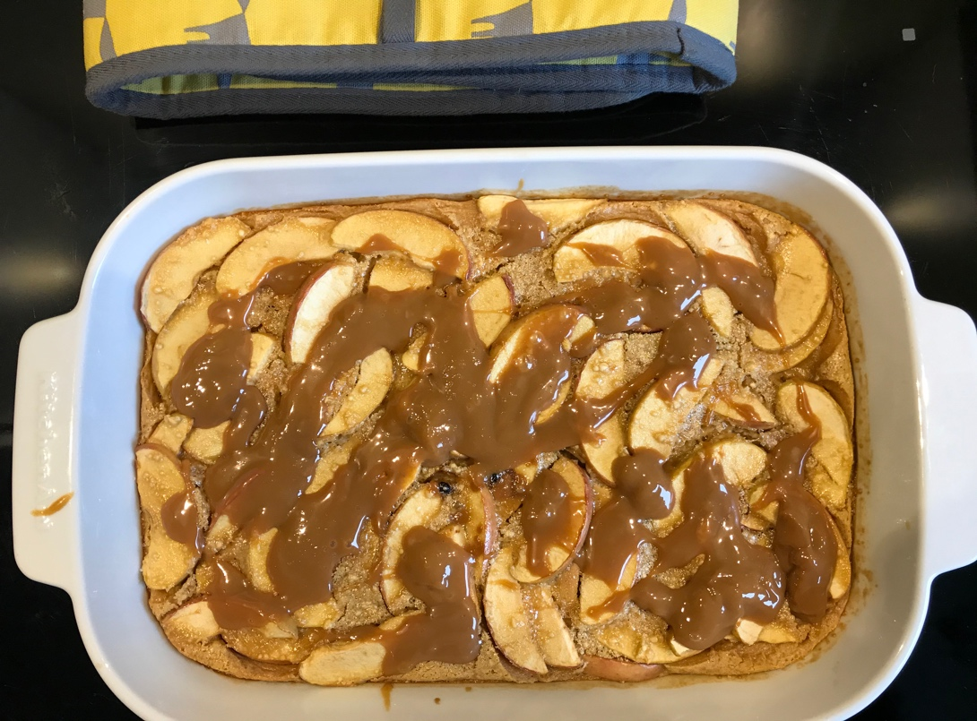

Ingredients
- 1 tbsp butter, softened.
- 3 large eggs, and 2 egg yolks.
- 50g dark brown soft sugar.
- 200ml whole milk.
- 300ml double cream.
- 375g can caramel, beaten until smooth.
- 2tsp vanilla extract.
- 75g plain flour
- 3 apples (pink ladies are best)
- Ice cream to serve (optional)

Method

- Heat the oven to 108C/160C fan/gas 4. Butter a 30x20x4 cm baking dish. Put the eggs, extra yolks, sugar, milk, cream, 200g of the caramel, the vanilla and a large pinch of sea salt in a large bowl, then whisk until combined. Stir in the flour until the batter is smooth.
- Halve, core and cut the apples into 1cm slices – there’s no need to peel them. Arrange them in the baking dish and pour over the batter. Bake for 30-35 mins until the batter is set in the centre, golden and slightly risen.
- Drizzle over the remaining caramel, then sprinkle with a little extra sea salt. Leave to rest for 5-10 mins (it will deflate a little). Serve warm with vanilla or peanut butter ice cream, if you like.

And that’s how you make a Salted caramel & apple pudding.

