Dylan’s Recipe.

Vegan Quorn and vegetable wraps

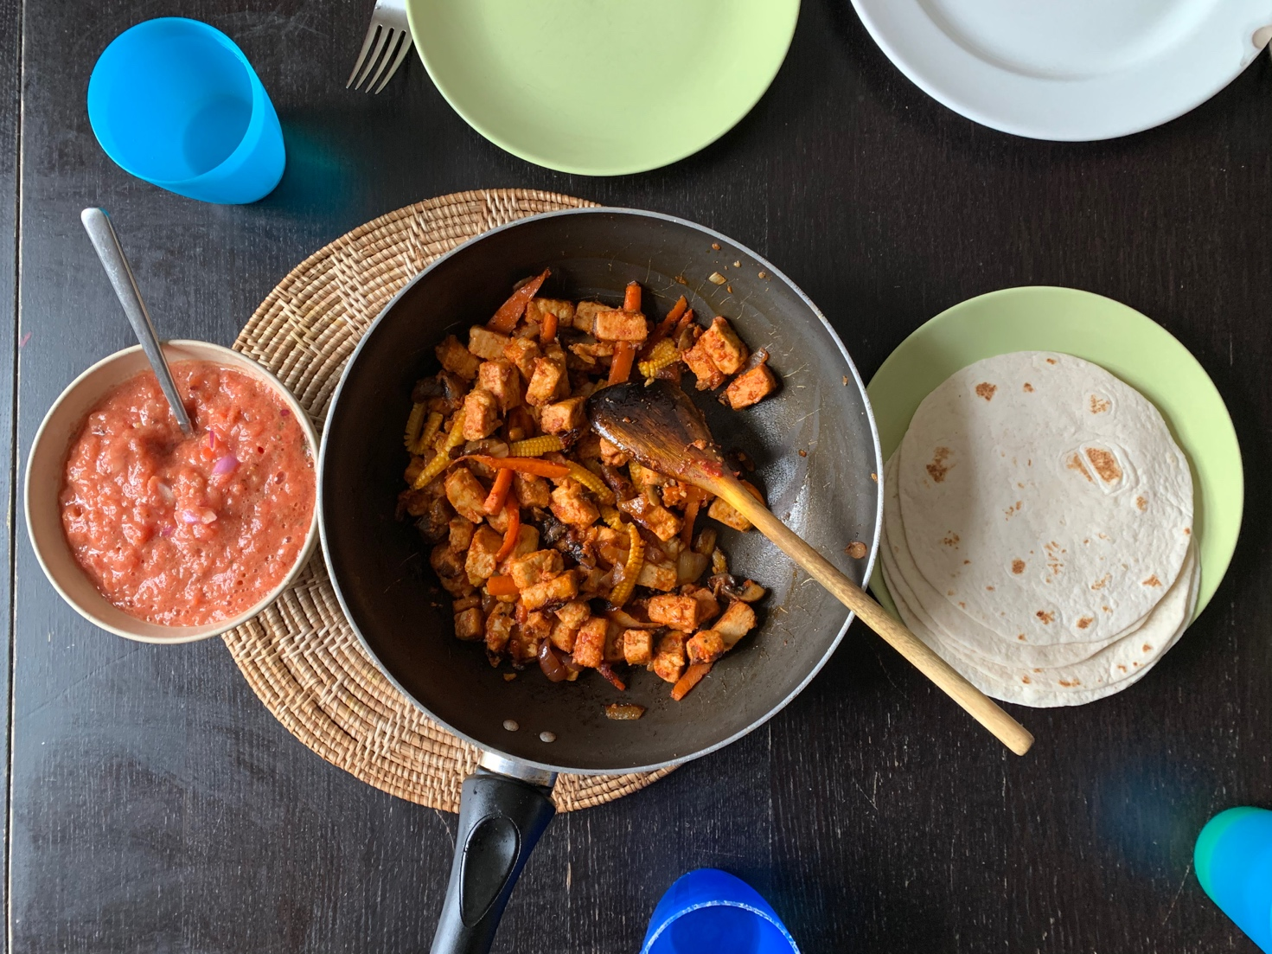

The inspiration:
This is inspired by Mexican food and I made it because this is something that me and my brother and sister enjoy.

Ingredients:
Vegan Quorn pieces
Red onion
Thinly sliced vegetables (carrot, babycorn, green pepper or whatever you like the best!)
Tomato puree (1 tbs)
Seasoning (1tps of paprika, ½ tps cayenne pepper, salt and pepper)
Wraps

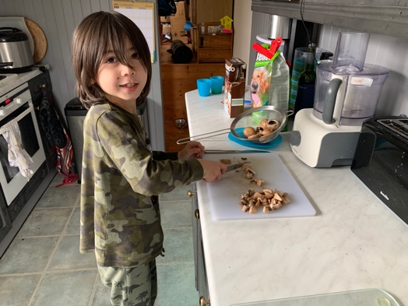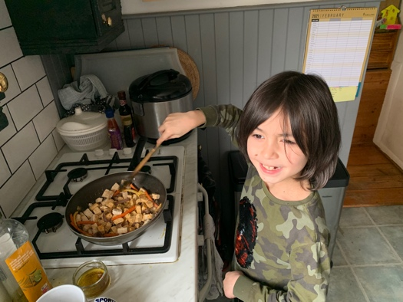

Instructions:

Chop the onion and fry in olive oil in a frying pan. When the onion is soft add the sliced vegetables and stir fry for 5 minutes. Then add the Quorn pieces, the seasoning and puree.
Cook for another 5 minutes.
Warm the wraps in a microwave and then you’re ready to serve!

You can also enjoy the wraps with a homemade salsa: use a food processor to blend tomatoes, a teaspoon of tomato puree, 1 garlic clove, 1 teaspoon of coriander leaf and the juice of 1 lime. Add some chilli flakes if you don’t mind it being a bit spicey!

