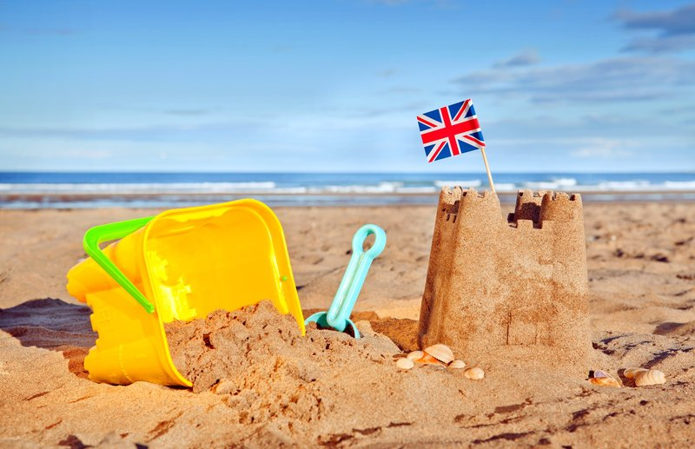
Science:
This half term, we will continue to learn about plants and We will investigate how water, light and temperature affect plant growth.

RFC Event:
Year 2 Disco – 12th June 4.30pm-5.30pm

Health and Wellbeing:
Sports Day
16th June 9:30 – 11.30am

Enrichment:
Trip to Littlehampton – 14th July

Year 2 – Summer 2
‘Why do we love to be beside the seaside?

PE:

The PE focus for this half term is
Dance. Children will create and perform their own dances, developing rhythm, coordination and expression

PE Days:

Zircon – Wednesday and Thursday Onyx – Tuesday and Thursday

This half term, we will begin our Literacy unit by writing a mystery sequel to Flotsam by David Wiesner. Children will immerse themselves in the story through drama and role play. In addition, we will explore different types of poetry and write our own poems. Children will also write postcards linked to seaside locations.
In Geography, we will develop our understanding of key vocabulary related to the seaside. Children will learn to describe physical features such as coasts, cliffs and vegetation, as well as human features including ports, harbours and villages. They will also use maps to locate coastal areas and explore life on islands such as Struay.
In History, we will explore how seaside towns have changed over time, from the Victorian era to the present day. Children will learn how aspects such as buildings, beaches and tourism have evolved, and how seaside holidays in the past compare to those today. We will also learn how to stay safe at the beach in preparation for our seaside trip.

Maths:
This half term, we will learn how to find halves and quarters of amounts, measure in cm and m, g and kg, ml and l. We will also compare and sort 3D shapes.
We will continue to practise counting in 3’s and well as learn our 2, 5 and 10’s times tables.

C
Computing:

This half term the children will become photographers. This will involve learning how to use technology purposefully to create, organise, store, manipulate and retrieve digital content.

Useful links: Subject curriculum maps Year 2 school webpage National curriculum

Please don’t hesitate to contact us if you have any queries about your child’s progress. The year group email is year2@rockmount.croydon.sch.uk

