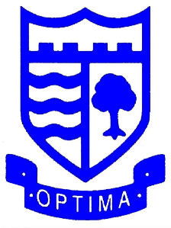
Headteacher: Helen Carvall

Deputy Headteachers: Amber Pearless
Vivian Bull

Tel: 020 8653 2619

office@rockmount.croydon.sch.uk
Rockmount Primary School
Chevening Road
Upper Norwood
London
SE19 3ST

www.rockmountprimaryschool.co.uk
ALL CAN ACHIEVE

21st May 2026

No Pens Day – Friday 22nd May 2026
Dear Parents and Carers,

We are delighted to announce that Rockmount Primary School will be taking part in our very own version of No Pens Day tomorrow, Friday 22nd May.
What is No Pens Day?
For one extra-special day, there is no writing allowed – it’s all about talking and listening. And remember, talking includes speech, signs, symbols, tech, and so much more! Instead, we’ll ask pupils to take part in a day of activities that put speech, language, and communication first.
Why are we taking part?
Nationwide, 1 in 5 children are struggling with talking and understanding words. Without the right support, they’re left out and left behind, made to feel as though they’ve failed before their futures have even begun. Things like sharing a joke with friends, learning new things in class, and joining in with games can all be out of reach.
By taking part in No Pens Day, we hope to raise awareness of the importance of communication skills while giving the children a fun and memorable learning experience.
We would also greatly appreciate any voluntary donations towards this cause. Any money raised will go directly towards purchasing Speech and Language resources for the school. If you would like to contribute, please send your donation into school with your child tomorrow.
We hope all the children enjoy participating in No Pens Day!
Thank you for your continued support.

The Rockmount Team

