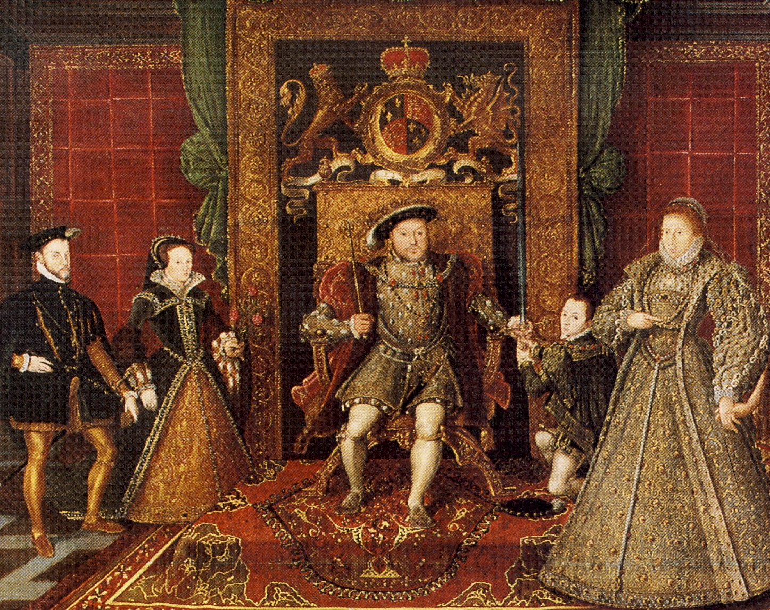
Wider Curriculum
Health and Wellbeing:
Children’s Mental Health Week

Enrichment:
National Portrait Gallery tbc

PSHE:
Citizenship: focusing on the justice system, how Parliament works, the role of pressure groups, and the importance of rights, responsibilities, and community contribution.
Year 5 – Spring 1
Who were the Tudors?
Science
The theme for this half term is ‘Living Things and Life Cycles’ . The children will learn about the reproduction of plants, mammals, metamorphosis and comparing life cycles.

PE
The PE focus for this half term is Gymnastics. The children will create complex sequences, lead groups, develop symmetry, and evaluate performances to improve key elements like timing and flow.
PE & Swimming
Sapphire Monday and Tuesday
Moosntone Monday: Swimming

This term, we will journey back to the Tudor era to uncover how this remarkable period transformed life in England, with a particular focus on our local area. The children will trace key events and developments in Tudor history, discovering how these changes shaped our community over time. By exploring significant local Tudor sites and stories, they will gain a deeper understanding of how national events, such as the reign of Henry VIII and the English Reformation, were reflected in our locality.
In English, our focus texts are, The Eyewitness Guide to All Things Tudor and Treason by Berlie Doherty which will inspire children as they develop their narrative writing skills and craft and write clear, well-structured instructions.
In art, we will explore What makes a portrait ‘great’? .Children will study Tudor portraits, refine their ideas in sketchbooks, and improve their drawing skills using materials like pencil and charcoal to create their own impressive artwork.

Maths
This half term, the focus will be on developing the 4 operations + , - , x and ÷. There will be a focus on learning times tables up to 12 and using Times Table Rockstars.

RE
In RE, the children will focus on the question ‘In what ways are people judged?’. We will
learn about hate crimes, anti-bullying strategies, and Anne Frank’s story during the Holocaust.

Useful links: Year 5 School Webpage Curriculum Map National Curriculum
Please don’t hesitate to contact us if you have any concerns about your child’s progress. The year group email is year5@rockmount.croydon.sch.uk

Please don’t hesitate to contact us if you have any queries about your child’s progress. The year group email is: year5@rockmount.croydon.sch.uk

